

**Poona District Education Association’s**

**AnnasaheMagarMahavidyalaya**

**Hadapsar,Pune 411 028**

**A Project Report On**

**“ELECTRICITY BILLING SYSTEM”**

*Submitted in the partial fulfilment of the requirements for the award of the Degree of*

***Bachelor of business administration in computer application***

Submitted by

**Kumar MulekarAndPravinOhol**

Under the guidance of

**PROF.MANE A.C.**

Project Guide

**Department of BBA(CA)**

AnnasaheMagarMahavidyalaya

**Hadapsar,Pune 411 028**

**2020-21**

AnnasaheMagarMahavidyalaya

**Hadapsar,Pune 411 028**

**(PUNE UNIVERSITY,PUNE)**

**Department of BBA(CA)**

**CERTIFICATE**

Certified that the project work entitled **“ELECTRICITY BILLING SYSTEM”** carried out by **Mr.KumarMulekar and Mr.PravinOhol,** students of A.M.COLLEGE, PUNE in partialfulfilment for the award of the Degree of **Bachelor of Bussiness Administration in Computer Application** of the **Pune University,Pune**during the year **2020-21**. It is certified that all corrections/suggestions indicated for Internal Assessment have been incorporated in the report deposited in the departmental library. The project report has been approved as it satisfies the academic requirements in respect of project work prescribed for the said Degree.

Date : -

------------------------------------------------------------------------------------------------------------------------------------------

**Exam seat no : - Exam seat no :-**

**Project in charge Head Of Department**

**Internal Examiner External Examiner**

AnnasaheMagarMahavidyalaya

**Hadapsar,Pune 411 028**

**(Affiliated to PUNE UNIVERSITY, PUNE)**

**Department of BACHELOR OF BUSSINESS ADMINISTRATION IN COMPUTER APPLICATION**

**DECLARATION**

We, the students of **IV** semester **BBA(CA)**, **A.M.COLLEGE**,PUNE declare that the Project work entitled **“ELECTRICITY BILLING SYSTEM”** has been carried out by us and submitted in partial fulfilment of the course requirements for the award of degree in BACHELOR OF BUSSINESS ADMINISTRATION IN COMPUTER APPLICATION discipline of **PUNEUNIVERISTY,PUNE** during the academic year 2020-21. Further, the matter embodied in the dissertation has not been submittedpreviously by anybody for the award of any degree or diploma to any other university.

**KUMAR MULEKAR**

**PRAVIN OHOL**

**Place:**

**Date:**

**ABSTRACT**

Electricity consumers are often faced with the problem of inaccuracy and delay in monthly billing due to some drawbacks. Thus, it is essential to have an efficient system for such purposes via electronic platform with consideration to proximity. The proposed system automates the conventional process of paying electricity bill by visiting the Electricity Board which is tiresome and time consuming. It is also designed to automate the electricity bill calculation and payment for user convenience. The system is developed with Java swings as the base programming language which can be used to develop websites, web applications and web services. The Microsoft Structured Query Language (SQL) server is also used for creating back-end database. The system would be having two logins: the administrative and user login. The administrator can view the user's account details and can add the customer's information of consuming units of energy of the current month in their account. The Admin must feed the system with the electricity usage data into respective user’s account. The system then calculates the electricity bill for every user and updates the information into their account every month. Users can then view their electricity bill and pay before the month end.

**ACKNOWLEDGEMENT**

A project is a job of great enormity and it can‟t be accomplished by an individual all by them. Eventually, we are grateful to several individuals whose professional guidance, assistance and encouragement have made it a pleasant endeavour to undertake this project.

We are grateful to the Head of the Department **PROF.MANE A.C.,** for his unfailing encouragement and suggestion given to us duringour project work.

Guidance and deadlines play a very important role in successful completion of the project on time. We also convey our gratitude to our internal project guide,

**PROF.MANE A.C.,** for having constantly guided and the development of the project.

Finally, a note of thanks to the Department of Computer Science Engineering, both teaching and non-teaching staff for their co-operation extended to us. We thank our parents for their constant support and encouragement. Last, but not the least, we would like to thank our peers and friends.

**KUMAR MULEKAR**

**PRAVIN OHOL**

INDEX

**Abstract**

**Acknowledgement**

**Introduction**

* 1. Preamble
  2. Problem Statement
  3. Propose Solution

**Analysis and system requirement**

2.1Existing and propose system

2.2Software and hardware requirement

**System design and modelling**

3.1preliminary design

3.2 entity relationship diagram

* **ER Diagram**
* **Class Diagram**
* **Object Diagram**
* **Deployement Diagram**
* **Testing**
* **Form Design**
* **Data Dictionary**
* **Conclusion**
* **Biblography**

|  |  |  |  |  |
| --- | --- | --- | --- | --- |
|  |  |  |  |  |

**INTRODUCTION**

Electricity Billing System is a software-based application.

1. This project aims at serving the department of electricity by computerizing the billing system.
2. It mainly focuses on the calculation of units consumed during the specified time and the money to be charged by the electricity offices.
3. This computerized system will make the overall billing system easy, accessible, comfortable, and effective for consumers.

To design the billing system more service oriented and simple, the following features have been implemented in the project. The application has high speed of performance with accuracy and efficiency.

The software provides facility of data sharing, it does not require any staff as in the conventional system. Once it is installed on the system only the meter readings are to be given by the admin where customer can view all details, it has the provision of security restriction.

The electricity billing software calculates the units consumed by the customer and makes bills, it requires small storage for installation and functioning. There is provision for debugging if any problem is encountered in the system.

The system excludes the need of maintaining paper electricity bill, administrator does not have to keep a manual track of the users, users can pay the amount without visiting the office. Thus, it saves human efforts and resources.

**1.1 Preamble**

We, the owners of our project, respect all customers and make them happy with our service.

The main aim of our project is to satisfy customer by saving their time by payment process, maintaining records, and allowing the customer to view his/her records and permitting them to update their details.

The firm handles all the work manually, which is very tedious and mismatched.

The objectives of our project are as follows:

* To keep the information of Customer.
* To keep the information of consuming unit energy of current month.
* To keep the information of consuming unit energy of previous month.
* To calculate the units consumed every month regularly.
* To generate the bills adding penalty and rent.
* To save the time by implementing payment process online.

**1.2 Problem Statement**

The manual system is suffering from a series of drawbacks. Since whole of the bills is to be maintained with hands the process of keeping and maintaining the information is very tedious and lengthy to customer. It is very time consuming and laborious process because, staff need to be visited the customers place every month to give the bills and to receive the payments. For this reason, we have provided features Present system is partially automated(computerized), existing system is quite laborious as one must enter same information at different places.

**1.3 Proposed Solution**

1. This project system excludes the need of maintaining paper electricity bill as all the electricity bill records are managed electronically.
2. Administrator doesn't have to keep a manual track of the users. The system

automatically calculates fine.

1. Users don't have to visit to the office for bill payment.
2. There is no need of delivery boy for delivery bills to user's place. o Thus, it saves human efforts and resources.

**ANALYSIS AND SYSTEM REQUIREMENT**

**2.1 Existing and Proposed System**

The conventional system of electricity billing is not so effective; one staff must visit each customer’s house to note the meter readings and collect the data. Then, another staff must compute the consumed units and calculate the money to be paid. Again, the bills prepared are to be delivered to customers. Finally, individual customer must go to electricity office to pay their dues.

Hence, the conventional electricity billing system is uneconomical, requires many staffs to do simple jobs and is a lengthy process overall. In order to solve this lengthy process of billing, a web based computerized system is essential. This proposed electricity billing system project overcomes all these drawbacks with the features. It is beneficial to both consumers and the company which provides electricity.

With the new system, there is reduction in the number of staffs to be employed by the company. The working speed and performance of the software is faster with high performance which saves time. Furthermore, there is very little chance of miscalculation and being corrupted by the staffs.

**2.2 Software & Hardware Requirements**

**Hardware Requirements:**

* Hardware Specification: -Processor Intel Pentium V or higher
* Clock Speed: -1.7 GHz or more
* System Bus: -64 bits
* RAM: -16GB
* HDD: -2TB
* Monitor: -LCD Monitor
* Keyboard: -Standard keyboard
* Mouse: -Compatible mouse

**Software Requirements:**

* Operating System: -Windows 10
* Software: -Microsoft SQL Server
* Front End: -Java core/swings (NetBeans)
* Back End: -My SQL

**SYSTEM DESIGN AND MODELLING**

**3.1 Preliminary Design**

System design is an abstract representation of a system component and their relationship and which describe the aggregated functionally and performance of the system. It is also the plan or blueprint for how to obtain answer to the question being asked. The design specifies various type of approach.

Database design is one of the most important factors to keep in mind if you are concerned with application performance management. By designing your database to be efficient in each call it makes and to effectively create rows of data in the database, you can reduce the amount of CPU needed by the server to complete your request, thereby ensuring a faster application.

**3.1.1 Entity-Relationship Diagram**

An entity relationship diagram (ERD) shows the relationships of entity sets stored in a database. An entity in this context is an object, a component of data. An entity set is a collection of similar entities. These entities can have attributes that define its properties.

There are two reasons to create a database diagram. You’re either designing a new schema or you need to document our existing structure.

If you have an existing database you need to document, you create a database diagram using data directly from your database. You can export your data base structure as a CSV file (there are some scripts on how to do this here), then have a program generate the ERD automatically.

An ER diagram is a means of visualizing how the information a system produces is related. There are five main components of an ERD:

* Entities, which are represented by rectangles. An entity is an object or concept about which you want to store information.
* A weak entity is an entity that must defined by a foreign key relationship with another entity as it cannot be uniquely identified by its own attributes alone.
* Actions, which are represented by diamond shapes, show how two entities share information in the database.
* In some cases, entities can be self-linked. For example, employees can supervise other employees.
* Attributes, which are represented by ovals. A key attribute is the unique, distinguishing characteristic of the entity.
* A multivalued attribute can have more than one value. For example, an employee entity can have multiple skill values.
* A derived attribute is based on another attribute. For example, an employee's monthly salary is based on the employee's annual salary.
* Connecting lines, solid lines that connect attributes to show the relationships of entities in the diagram.
* Cardinality specifies how many instances of an entity relate to one instance of another entity. Ordinality is also closely linked to cardinality.

Figure 3.1.1 describes the ER diagram of Electricity Billing System. It has 5 entities namely login, customer, tax, bill, and meter info. The entities have attributes which are primary and foreign and attributes. The primary attributes are underlined.

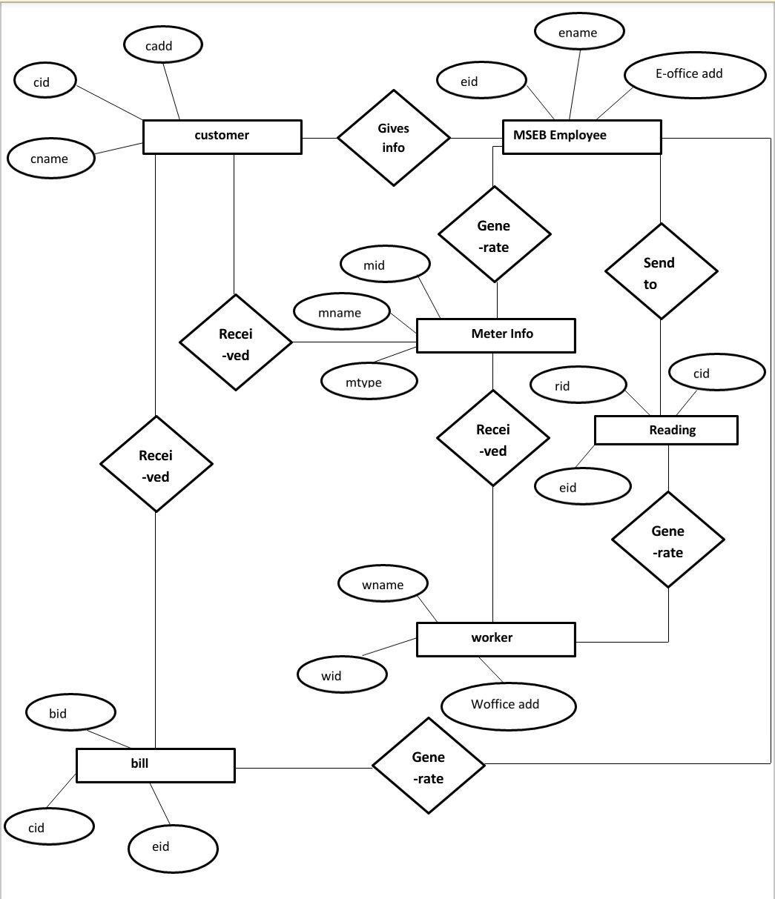

ER DIAGRAM

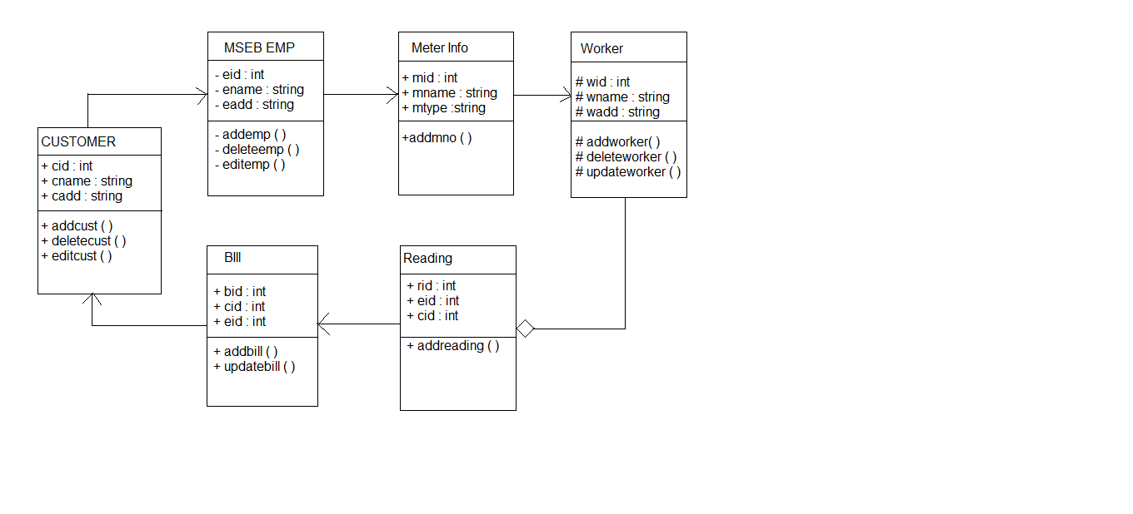

CLASS DIAGRAM

OBJECT DIAGRAM

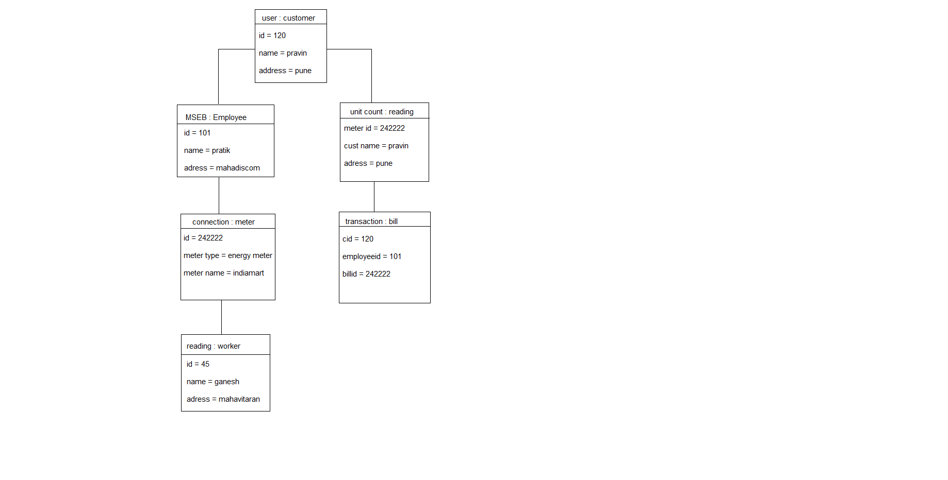

Deployement Diagram

Client server

Office server

Worker device

Client server network

office

Network server

**TESTING**

This chapter gives the outline of all the testing methods that are carried out to get a bug free application.

**5.1 Testing process**

Testing is an integral part of software development. Testing process, in a way certifies, whether the product, that is developed, compiles with the standards, that it was designed to. Testing process involves building of test cases, against which, the product has to be tested. In some cases, test cases are done based on the system requirements specified for the product/software, which is to be developed.

**5.2 Testing objectives**

The main objectives of testing process are as follows:

* Testing is a process of executing a program with the intent of finding an error.
* A good test case is one that has high probability of finding an as yet undiscovered error.
* A successful test is one that uncovers an as yet undiscovered error.

**5.3 Levels of Testing**

Different levels of testing are used in the testing process; each level of testing aims to test different aspects of the system. The basic levels are unit testing, integration testing, system testing and acceptance testing.

**5.3.1 Unit Testing**

Unit testing focuses verification effort on the smallest unit of software design the module. The software built, is a collection of individual modules. In this kind of testing exact flow of control for each module was verified. With detailed design consideration used as a guide, important control paths are tested to uncover errors within the boundary of the module.

**Admin Login**

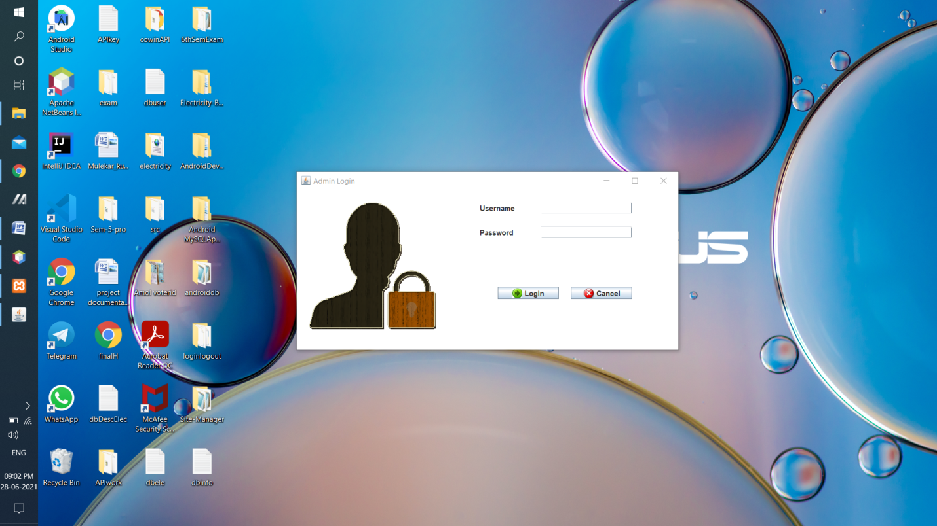

**New Customer**

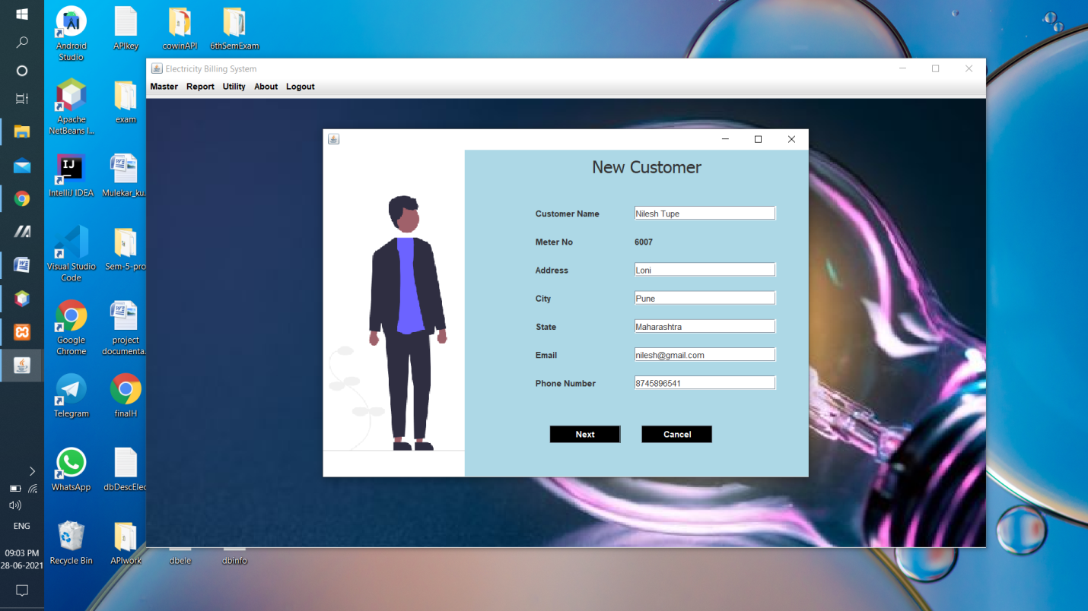

**Meter Information**

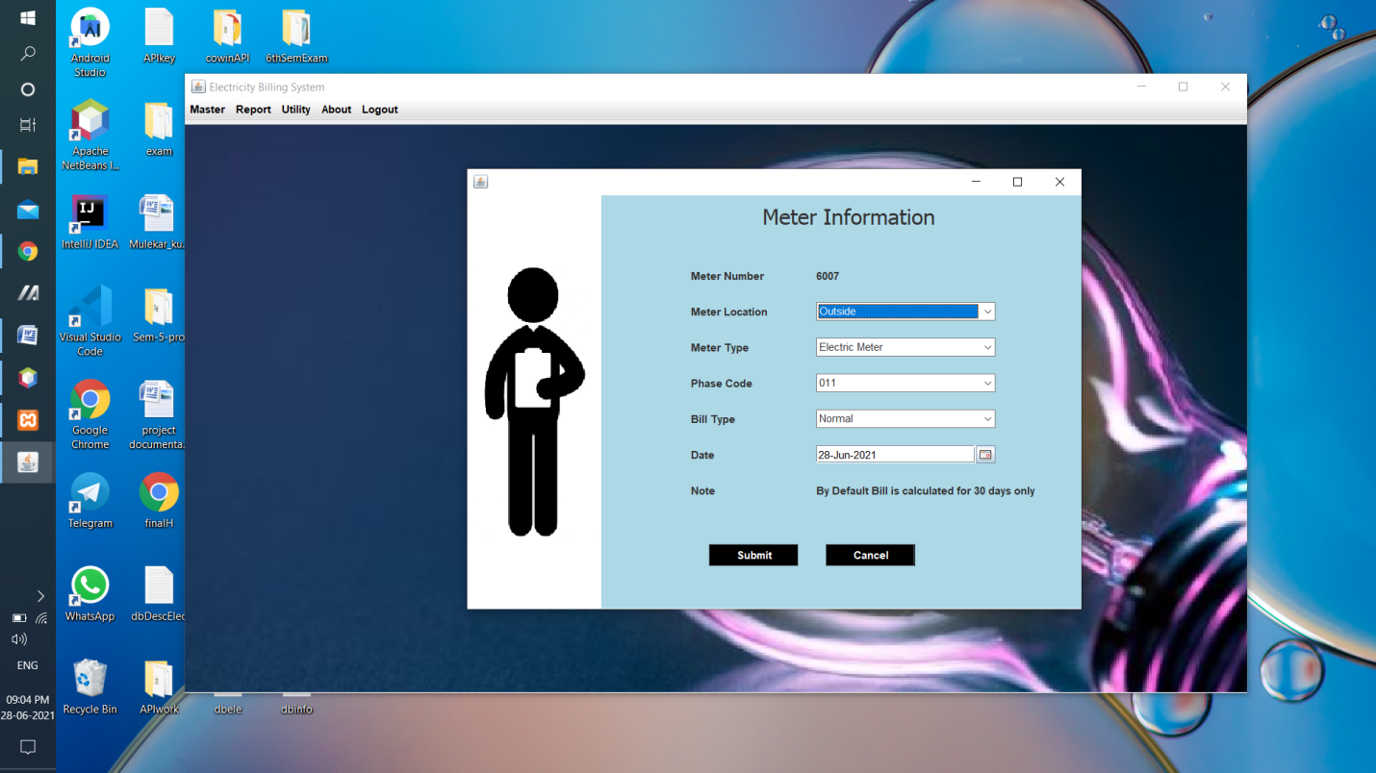

Bill Details Report

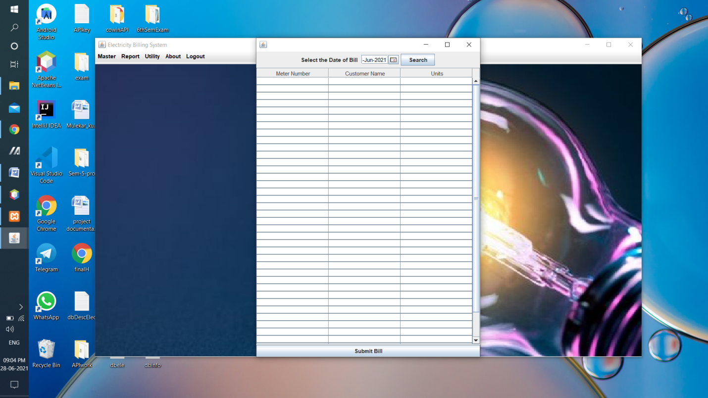

Admin Pay Bill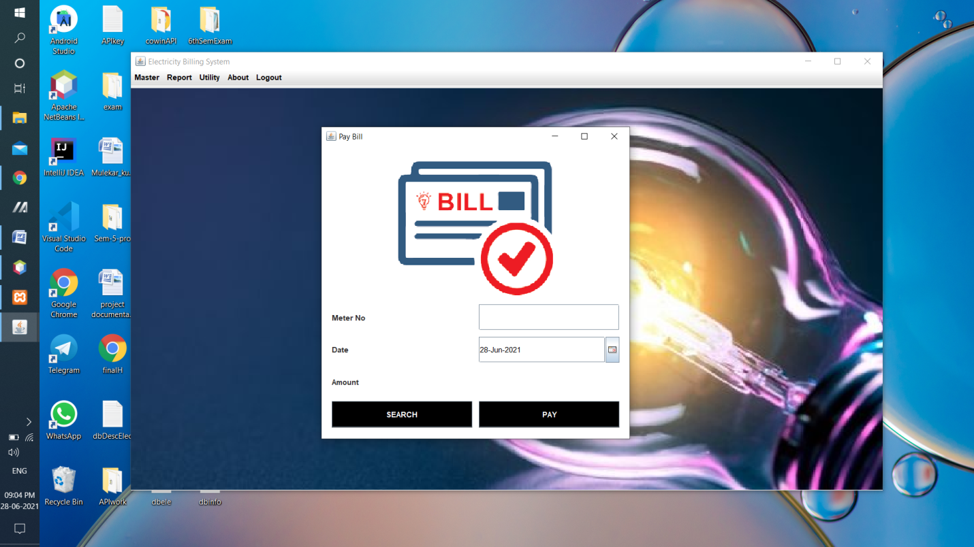

Customer Details Report

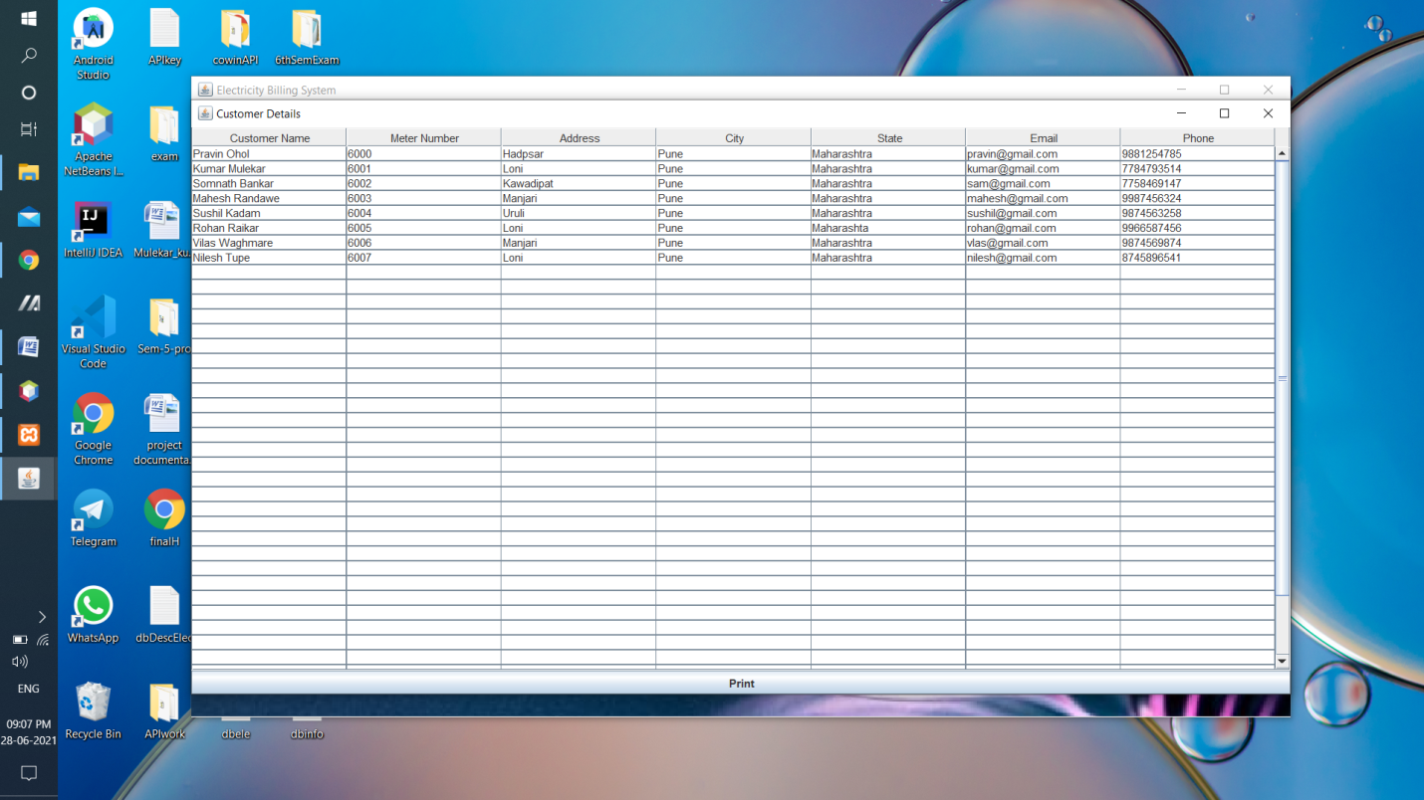

Deposit Details Report

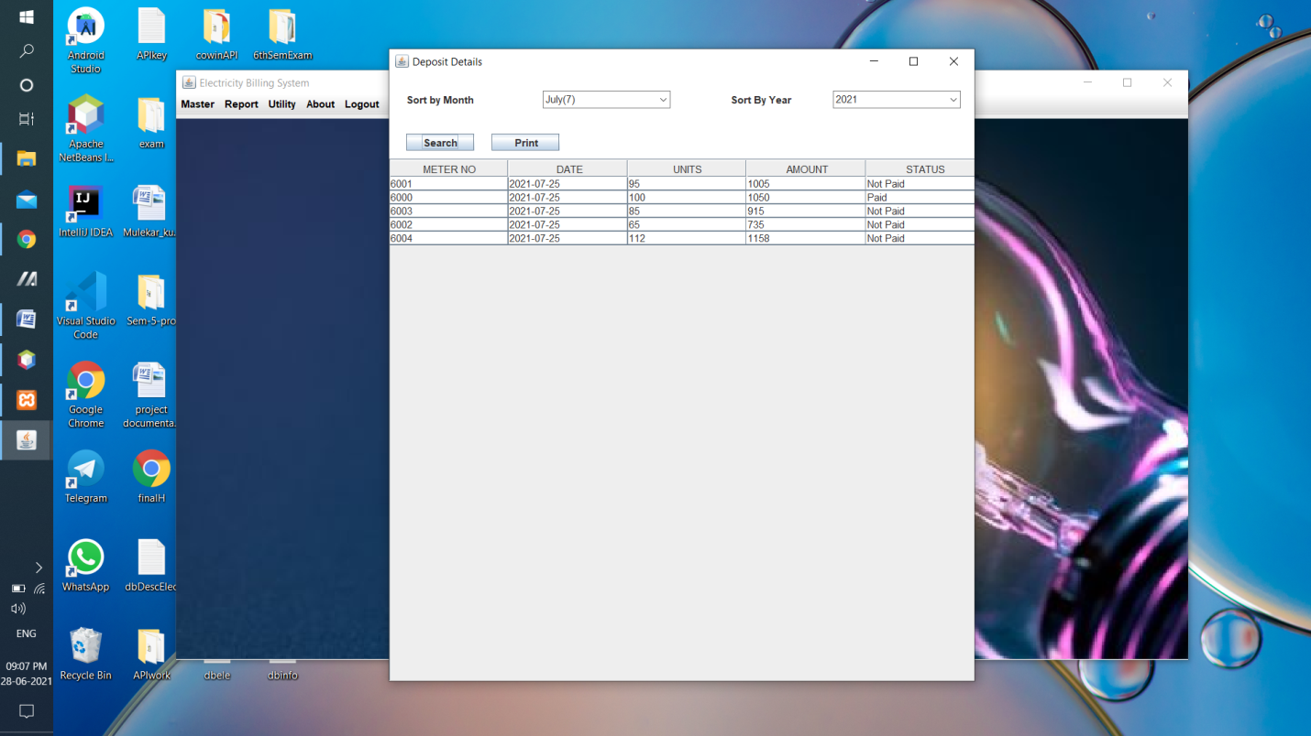

About Project

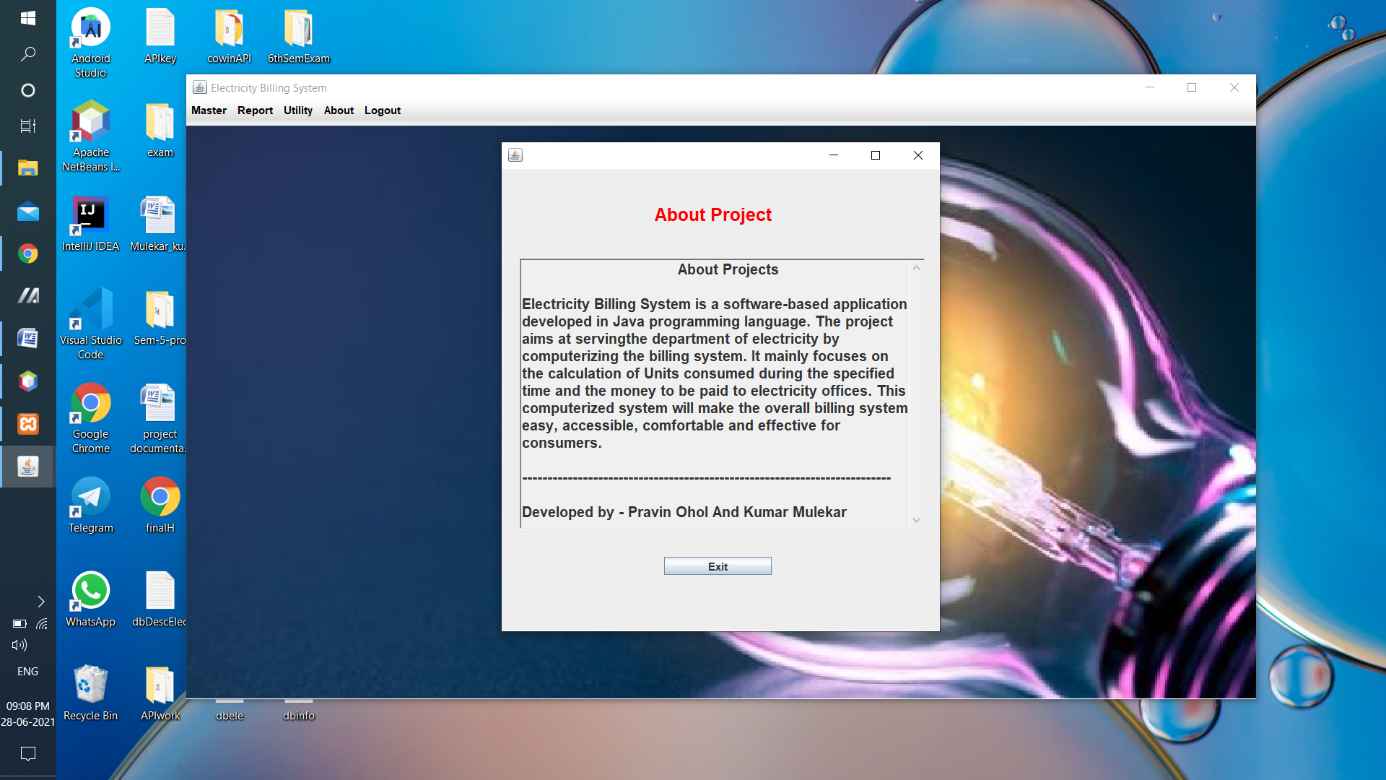

Customer Login

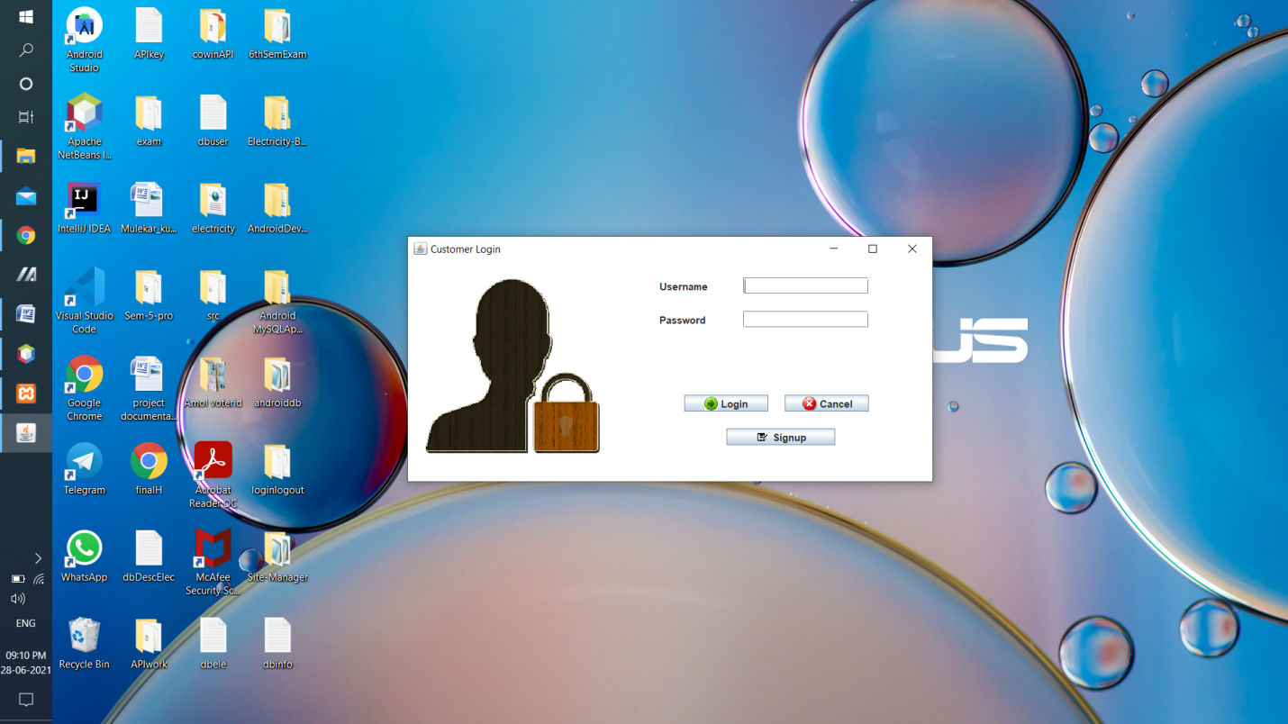

Customer Sign Up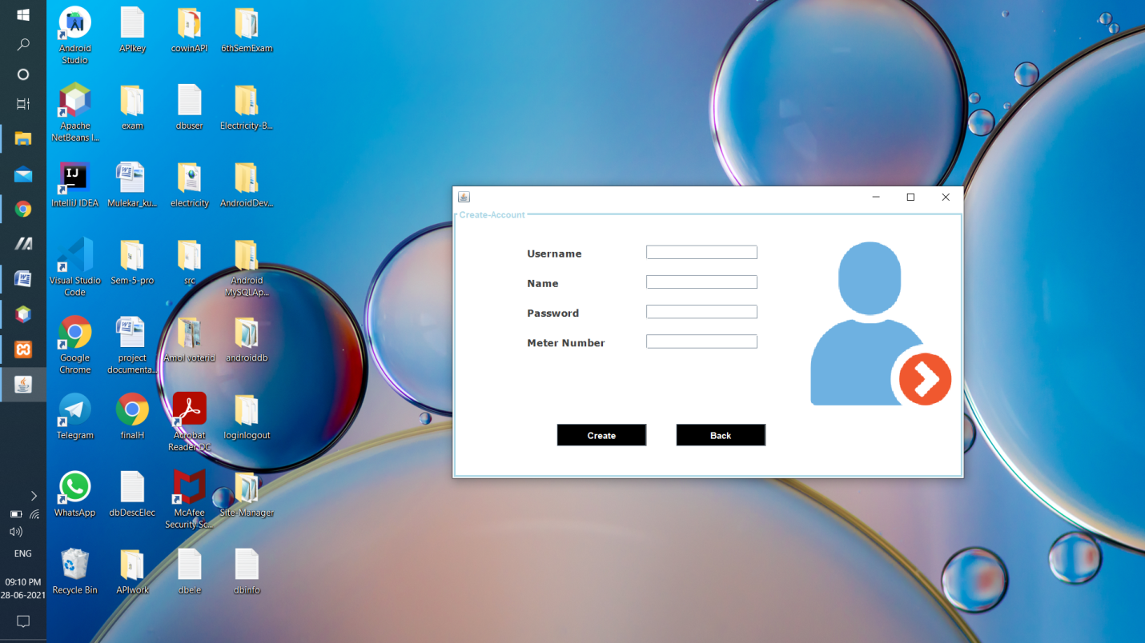

Main Form

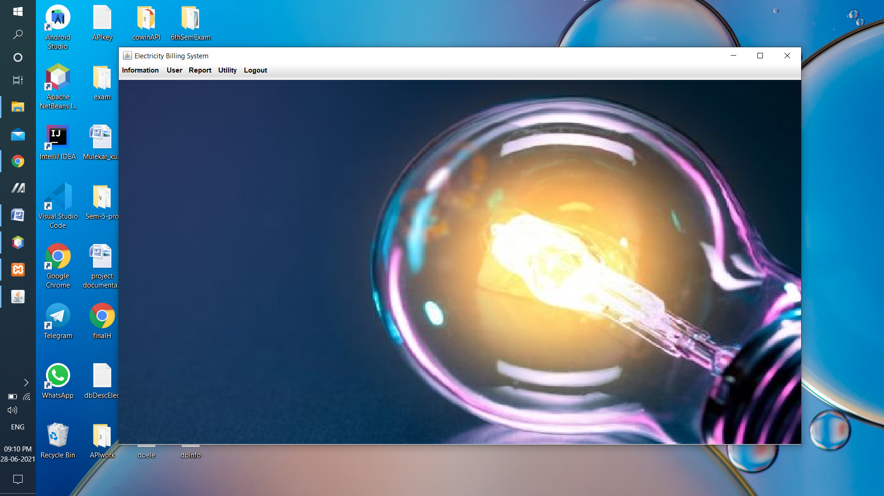

View Customer Details

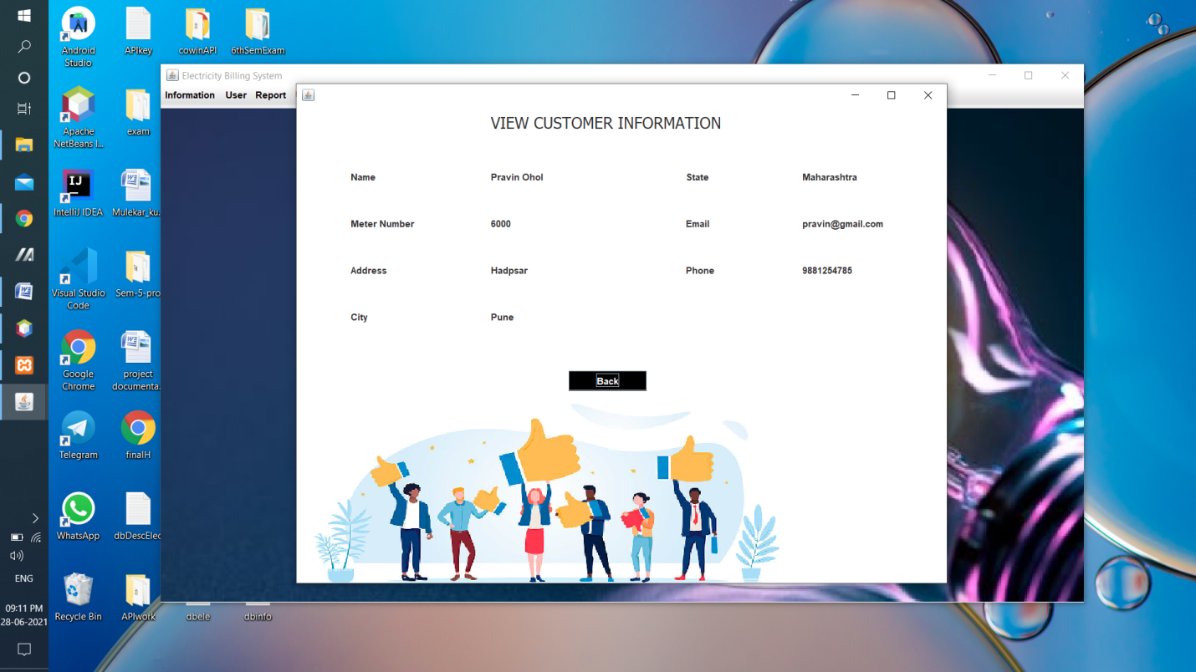

Update Customer Details

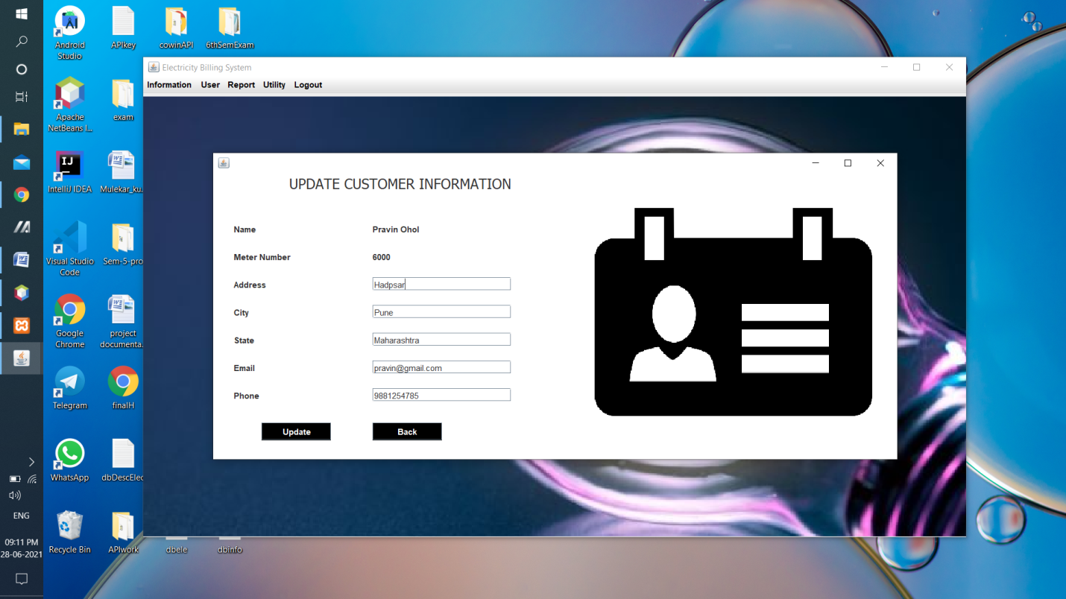

Customer Bill Pay

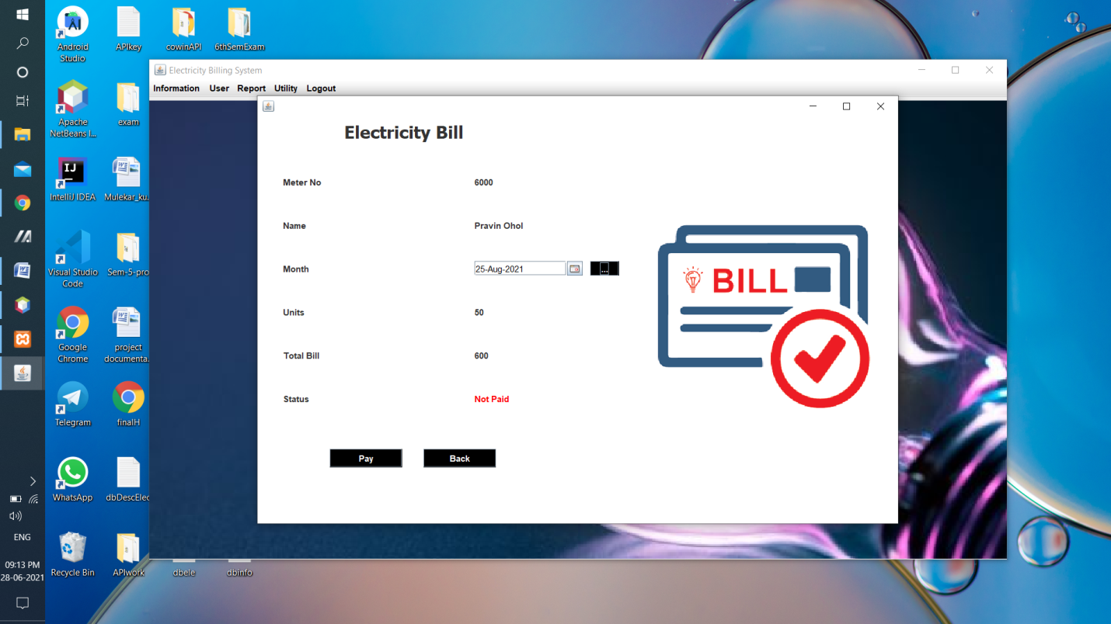

Bill Details Report

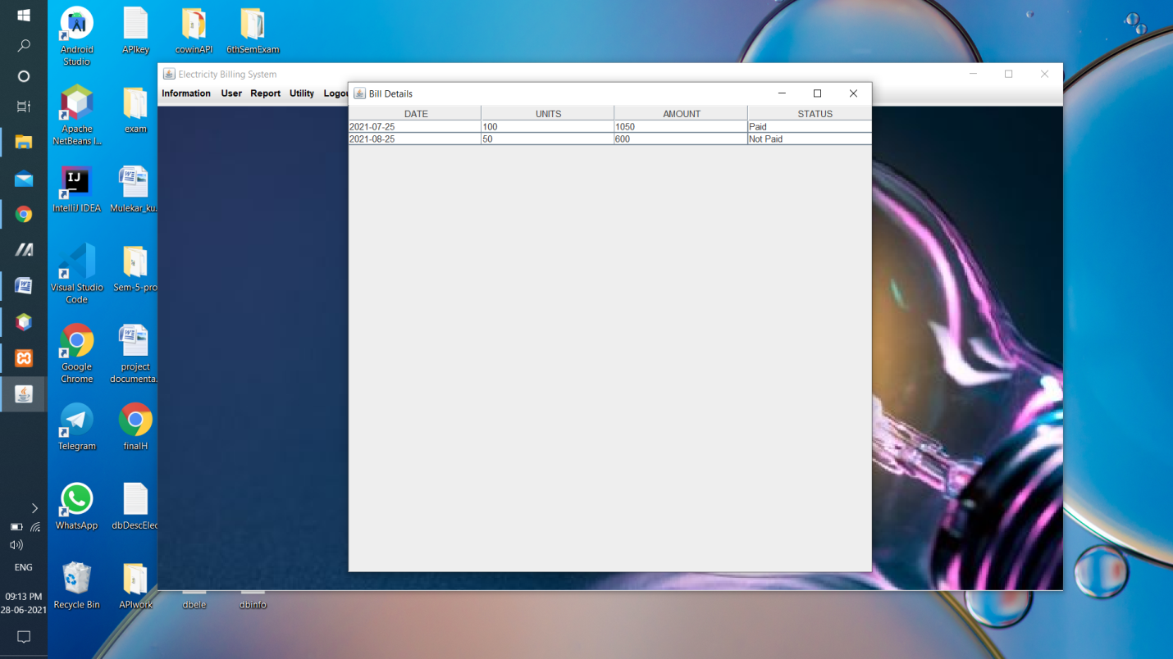

Generate Bill Report

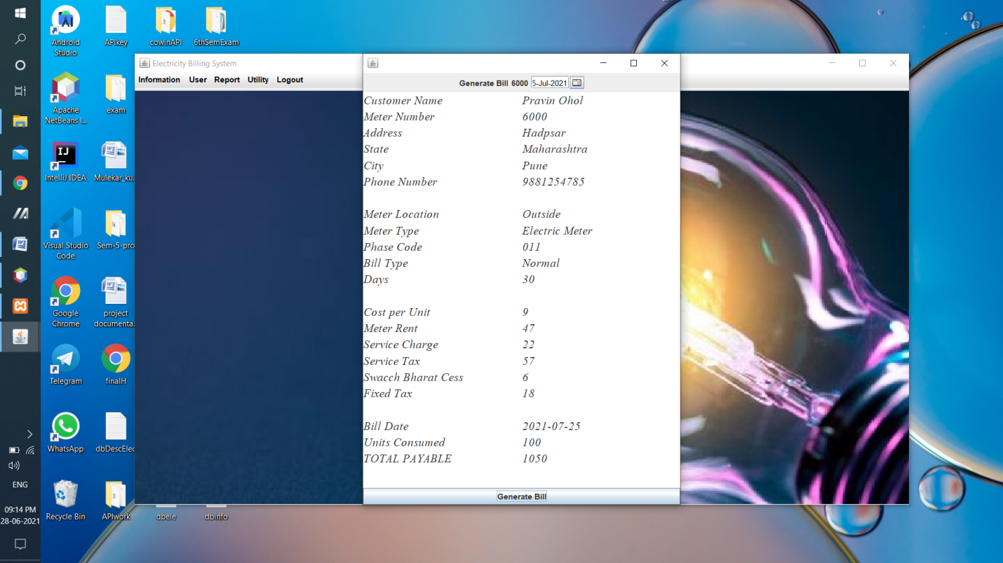

Worker Login

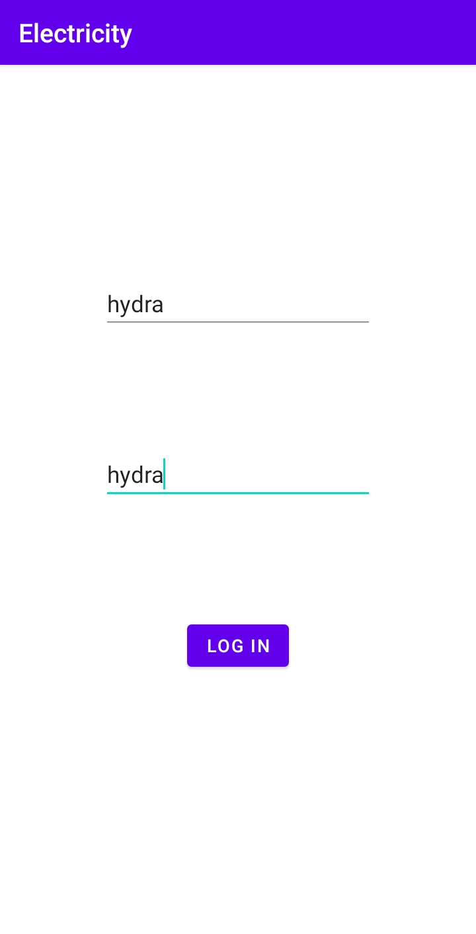

Customer Details

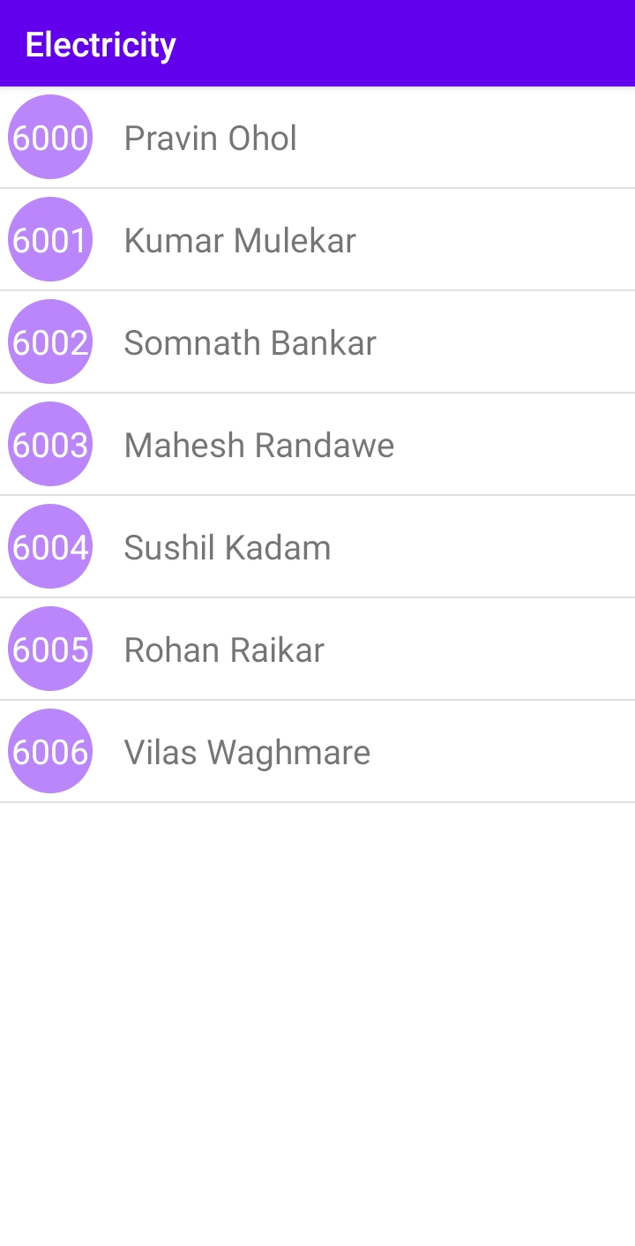

Submit Reading

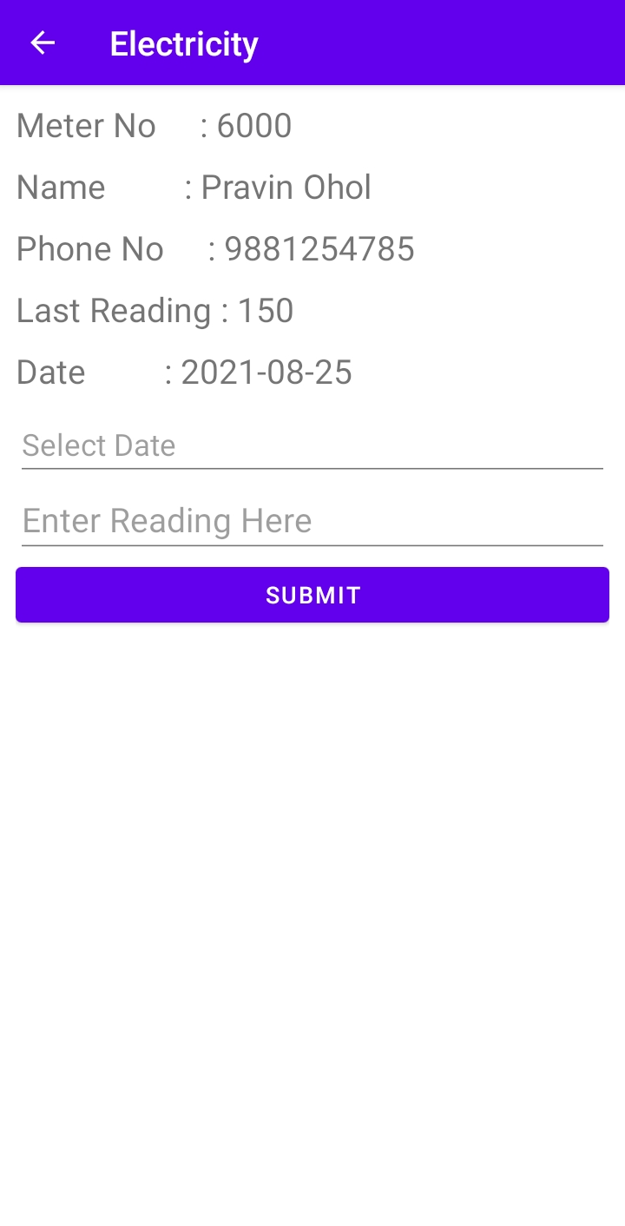

Tables_in_ebs

bill

customer

login

meter_info

reading

tax

|  |  |  |
| --- | --- | --- |
| Field | data Type | table name |
| meter | varchar(20) | bill |
| units | varchar(20) | bill |
| total_bill | varchar(20) | bill |
| status | varchar(20) | bill |
| bdate | date | bill |
| total_unit | varchar(20) | bill |

|  |  |  |
| --- | --- | --- |
| Field | data Type | table name |
| name | varchar(30) | customer |
| meter | varchar(20) | customer |
| address | varchar(50) | customer |
| city | varchar(20) | customer |
| state | varchar(30) | customer |
| email | varchar(30) | customer |
| phone | varchar(20) | customer |

|  |  |  |
| --- | --- | --- |
| Field | data Type | table name |
| meter_no | varchar(20) | login |
| username | varchar(30) | login |
| name | varchar(30) | login |
| password | varchar(30) | login |
| user | varchar(30) | login |

|  |  |  |
| --- | --- | --- |
| Field | data Type | table name |
| meter_number | varchar(20) | meter info |
| meter_location | varchar(20) | meter info |
| meter_type | varchar(20) | meter info |
| phase_code | varchar(20) | meter info |
| bill_type | varchar(20) | meter info |
| days | varchar(20) | meter info |
| last_date | date | meter info |
| last_unit | varchar(20) | meter info |

|  |  |  |
| --- | --- | --- |
| Field | data Type | table name |
| meter | varchar(20) | reading |
| reading | varchar(20) | reading |
| rdate | date | reading |

|  |  |  |
| --- | --- | --- |
| Field | data Type | table name |
| cost_per_unit | varchar(20) | tax |
| meter_rent | varchar(20) | tax |
| service_charge | varchar(20) | tax |
| service_tax | varchar(20) | tax |
| swacch_bharat_cess | varchar(20) | tax |
| fixed_tax | varchar(20) | tax |

**CONCLUSION**

After all the hard work is done for electricity bill management system is here. It is a software which helps the user to work with the billing cycles, paying bills, managing different DETAILS under which are working etc.

This software reduces the amount of manual data entry and gives greater efficiency. The User Interface of it is very friendly and can be easily used by anyone.

It also decreases the amount of time taken to write details and other modules.

**BIBLIOGRAPHY**

**REFERENCES**

**Book Reference**

Database Management Systems 3rd Edition by Raghu Ramakrishnan (TEXTBOOK).

**Websites**

* <https://www.youtube.com/watch?v=iL_5MhKSSN0&list=PL5BFcXE899zxmT9vmSuleorXKrxjOOErp> (Code for Interview YouTube Channel)
* <http://www.github.com>
* [www.youtube.com](http://www.youtube.com/)
* [www.stackoverflow.com](http://www.stackoverflow.com/)
* [www.google.com](http://www.google.com/)
* <http://www.javatpoint.com/>